**San Francisco Bay University**

**EE553 - System on Chip (SoC) Design**

**Homework Assignment #3**

**Due day: 3/16/2022**

**Student ID: 19590**

**Instruction:**

1. **Push the answer sheet to Github**
2. **Overdue homework submission could not be accepted.**
3. **Takes academic honesty and integrity seriously (Zero Tolerance of Cheating & Plagiarism)**
4. Implement switch controlled / push button controlled LEDs without the interrupt on Zybo Z7-10 board following the instructions in lab manuals on Canvas week#9 module

**LEDs Control by Switches:**

1. Launch Vivado
2. Create a project
3. Create a block design

4. Create HDL module

5. Create the bitstream

6. Export the file

7. Launch SDK and create application project

8. Import the C Program

9. Connect Zybo Z7-10 to your computer and check serial port

10. Compile C Program

11. Set up the display terminal for the print

12. Download bitstream to PL and run the program

**Output Link:**

<https://photos.app.goo.gl/jDEfuHFhai9gv9Cn7>

**LEDs Control by Push Buttons:**

1. Launch Vivado
2. Create a project
3. Create a block design

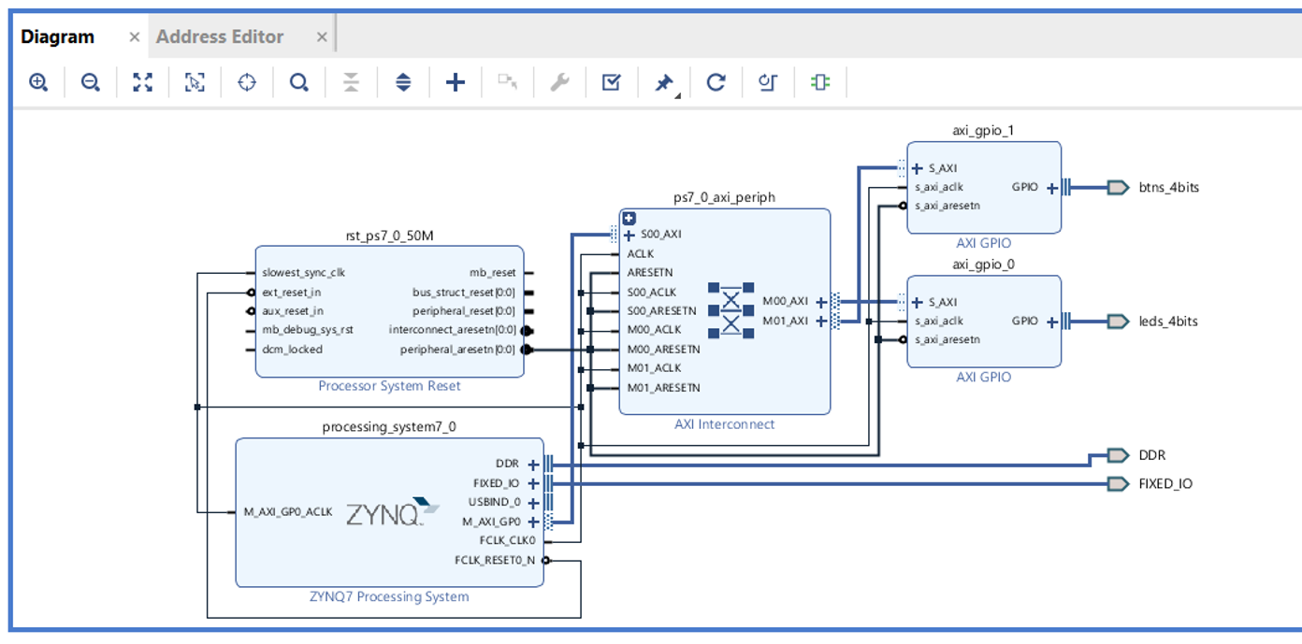

4. Create HDL module

5. Create the bitstream

6. Export the file

7. Launch SDK and create application project

8. Import the C Program

9. Connect Zybo Z7-10 to your computer and check serial port

10. Compile C Program

11. Set up the display terminal for the print

12. Download bitstream to PL and run the program



**Output Link:**

<https://photos.app.goo.gl/V8upRVBLdHC42qEw7>

1. Complete BRAM memory read and write operations on Zybo Z7-10 board following the instructions in lab manuals on Canvas week#9 module

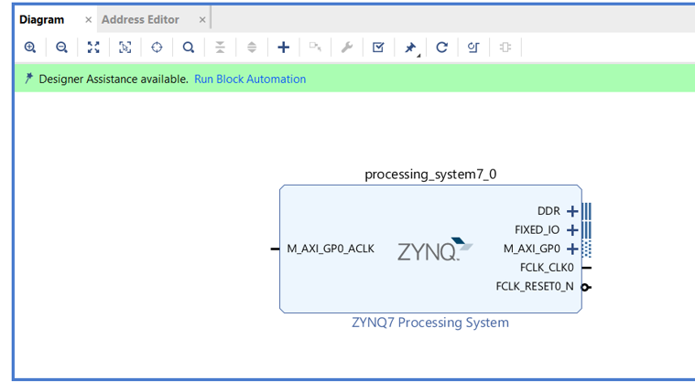

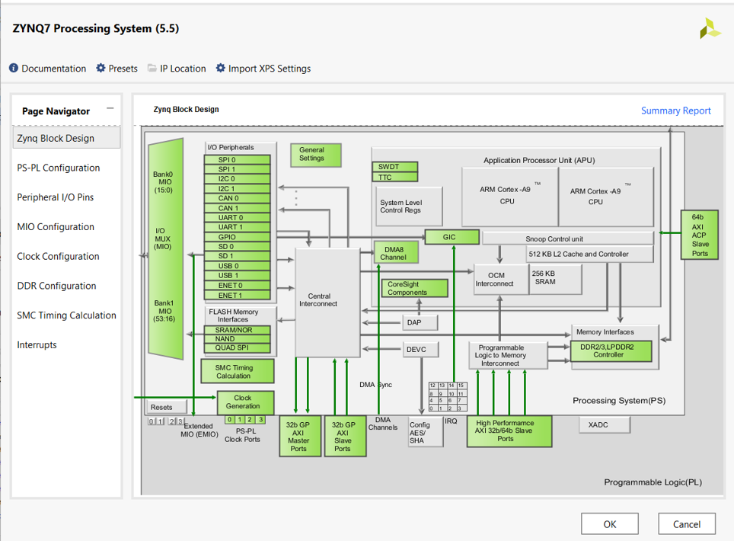

Professor, I tried multiple times but always ended up with this error that “platform.h” is not available as below.

